

**LABASA SANGAM**

**(SKM) COLLEGE**

**YEAR 13**

**COMPUTER PROJECT**

**2022**



NAME: kevin maskin khan

INDEX: 837760

YEAR: 13b

TEACHER: Mrs Mrs N.N.Ahmad

# SCHOOL WEB DESIGN

**LABASA SANGAM (SKM) COLLEGE**

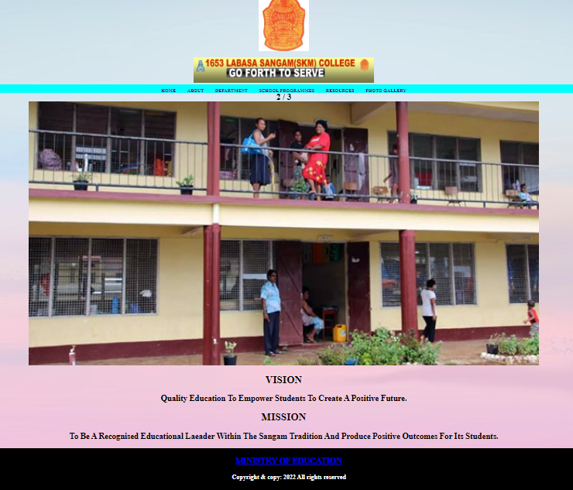

# AIM

To apply the knowledge and skills learnt in the following topic to create and complete website that is most benefiting for Labasa Sangam (SKM) college.

* Web designing

# OBJECTIVE

The objective of this project is to:

* Explain the primary role and responsibilities of a web designer.
* Use the first four phase of a web design life cycle that is:
* Phase 1: Website Planning
* Phase 2: Website Content
* Phase 3: Website Design
* Phase 4: Website Construction to complete this project.
* Gather information from Labasa Sangam(SKM) College and construct a website for the school using notepad and html.
* Benefits of having a website for school.

# ACKNOWLEDGEMENT

It is my profound pleasure to acknowledge the following people who have helped me in successfully completing this project:

* Firstly, the Almighty God, for showering his blessing and strength upon me in order for me to successfully complete this project.
* Secondly, my sincere appreciation and gratitude goes to Mrs N.N.Ahmad, my computer teacher, for her guidance, constructive comments, valuable suggestions and inspiration during the compilation of this project.
* Thirdly, to my parents for giving me this opportunity to do this project and financially helping me out.
* Last but not the least, my friends for their continuous support and guidance throughout this project

# DECLARATION OF ORIGINALITY

This is to certify that to the best of my knowledge, the content of this thesis is my own work. This thesis has not been submitted for any degree or other purposes. I certify that the intellectual content of this thesis is the product of my own work and that all the assistance received in preparing this thesis and sources have been acknowledged.

Kevin

Signature

19/07/2022

Date

# METHODOLOGY

* **Primary research:**

**Questionnaires**: A lot of inquiries were planned and were given to different partners, network individuals and offices in school on current desires for people in online administration by firms**.**

**Observations**: As a total member, perception was made on the different sound conduct and different changes in the customer condition among understudies, educators and the educational system all in all.

* **Secondary research:**

**Interne**t: Numerous sites were gotten to pick up data on the PC system, topology and result.

**Textbooks**: Various reference writings were utilized to get data pertinent to the examination work.

**TABLE OF CONTENT**

Contents

AIM I

OBJECTIVE II

ACKNOWLEDGEMENT III

DECLARATION OF ORIGINALITY IV

METHODOLOGY V

INTRODUCTION 1

ROLES AND RESPONSIBILITY 3

DEVELOPMENT OF WEBSITE 4

PHRASE 1: WEBSITE PLANNING 5

PHRASE 2: WEBSITE CONTENT 6

PHRASE 3: WEB DESIGN 8

PHASE 4: WEBSITE CONSTRUCTION 11

WEBSITE WIFEFRAMES 13

WEBPAGE - HOME 19

WEBPAGE - ABOUT 20

WEBPAGE - DEPARTMENT 21

WEBPAGE - SCHOOL PROGRAMME 22

WEBPAGE - RESOURCES 23

WEBPAGE – PHOTO GALLERY 24

CODING - HOME 25

CODING - ABOUT 27

CODING - DEPARTMENT 30

CODING - SCHOOL PROGRAM 37

CODING - RESOURCES 40

CODING – PHOTO GALLERY 42

RESULTS 45

CONCLUSION VII

REFERENCE VIII

# INTRODUCTION

A website may be an assortment of related districts, as well as intuitive media system content, for the most part known with a standard name, and engraved on no less than one web server. a web page could moreover be open through a public web Protocol (IP) association, like the web, or a singular nearby space association (LAN), by alluding to a standard resource assessor (URL) that perceives the arranging. Site may be a central area of varied objections that square measure all related and might be gotten to by visiting the house page using a program.

The World Wide web (WWW) was made in 1990 by British CERN man of science Tim Berners-Lee. On thirty Gregorian timetable months 1993, CERN declared that the globe Wide web would be cleared to use for anyone. Before the introduction of HTML and show, elective shows like File Transfer Protocol and in this manner the gopher show were adjusted recuperate individual records from a server. The first locales had straight plans, serious text and no outlines. The adding to a blog example of 2000 presented an inconceivably new period for locales. A weblog or web log is particularly to indicate a page. The term web log suggests a lot of blog segments, that square measure entirely objections. The composition for a blog instruments like Movable sort, Blogger, and Word Press offered a part for affiliation house owners to shape their destinations a lot of dynamic. Overall, the instruments were energetically something different. The house owners weren't introduced to the multifaceted nature of the essential system that continuously set free them to zero in on their site content. A basic part of those instruments was the flexibility to remember a page for the fly, with the gadgets dealing with the past complexity of making A HTML page. All through the remainder of the20th century to this point, the emerge of long reach casual correspondence, instructive locales, gaming destinations, dull destinations and things like YouTube that licenses individuals to shape their own extremely downsized video site. These days the web at whatever point choked with DIY destinations, where typical individuals put their living on-line. Some even structure their living from locales, for example eBay and Amazon square measure worldwide merchants, that all started with a site. Some web loggers get repaid to blog accepting adverts square measure showed in their accounts or on their pages; destinations have grown dreadfully quickly and can anyway do thusly. (Hopkins, 1979)

The web may be an association of related PCs. No association guarantees the web; it's a useful effort constrained by a game plan of standards and rules. The purpose in partner PCs along is to share information. There square measure various ways information is passed between PCs, as well as email, record move (FTP), and a ton of a lot of explicit modes upon that the web is created. These standardized approaches for moving data or records over an association square measure called shows. All through the drawn out the maxim "site design" has transformed into a procedure that integrates combination of various disciplines, from client dominance style, to report increment, to serious programming. Visual maker, writer, HTML essayist, and data fashioner square measure a few the task depictions related with composing a web page. Enormous extension locales square measure reliably made by a gathering, presenting from a few on bunches of. During this present circumstance, every person from the gathering revolves around one piece of the site-building technique. Web style is gathered into the subsequent four arrangements: style, headway, content method and blended media system. Site improvement may be a strategy for making a replacement site or executing changes to one as of now being utilized, model adding a critical new fragment to a live site.

A site expert is somebody WHO is each creative and as a matter of fact skewed, and uses each these properties to make or arrangement destinations. The electronic organizer has the versatility to make heads or tails of what's generally anticipated to shape a web page purposeful and clear to use, however at a relative time manufacture it elegantly intriguing to the client. There's piles to ponder inside the style of web objections which can't be forthwith clear once looking a webpage page for the fundamental time. The beautiful element is a crucial one and picking the sensible tones, literary style, organization and pictures makes the full demeaner of the site. In addition to considering upscale perspectives, the accommodation of the site should be fundamental. It's essential to shape a page that the goal market will interface with. For example, a web site expected for young people needs to hold their thought, and may use magnificent assortments and an easy to-grasp literary style, with stacks of pictures and not a nonsensical proportion of text. This can create it fun, interfacing with and direct to understand. The plan and development should be not difficult to follow, and most pages should not be too a couple of ticks significant into the site to stay the data simple to get to. The web based designer is adequate of the whole webpage and should see the strategy for conveying the proper picture while guaranteeing the webpage is not difficult to use and thusly the information is not difficult to get to.

A web working with may be an assistance that awards affiliations and people to post a web site page or web content onto the web. A web host, or web working with organization supplier, may be a business that has the developments and organizations expected for the website or page to be seen inside the web. Destinations square measure worked with, or set aside, on extraordinary PCs implied as servers.

Furthermore, the sharp site building incorporates server highlight setting up like PHP, ASP and CGI, destinations' visual component is shown with HTML and CSS, client authority is extended with dynamic JavaScript and Ajax. HTML is that the regular increment language for making areas. Basically every single person WHO is involved {the internet} or web preparing should have a fundamental understanding of in any case HTML works or HTML codes square measure formed. A HTML record contains "increment marks" that prompt the program the strategy for following headings among these names. This endeavour can convey a web site page misuse HTML in pad.

# ROLES AND RESPONSIBILITY

1. Explain the primary role as a Web Designer

Website architecture is a moderately new industry, having been made with the coming of the web, and is acquiring prevalence specifically throughout the course of recent years, as computerized media has turned into a significant piece of many individuals' lives. The vast majority depend on the web for their interchanges, data, shopping, public activity and that's just the beginning. The interest for website specialists has been developing quickly and the business is at present thought to be a decent one with connection to work possibilities and future development.

A website specialist creates and makes sites and related applications. Website specialists work in different enterprises and frequently as self-employed entities. A website specialist makes the look, design, and highlights of a site. The occupation includes understanding both visual depiction and PC programming. When a site is made, a fashioner assists with upkeep and increments to the site. They work with advancement groups or administrators for staying up with the latest and focusing on needs, among different errands.

A website specialist is somebody who is both inventive and in fact slanted, and utilizes both these properties to fabricate or overhaul sites. The website specialist can comprehend what is expected to make a site practical and simple to utilize, and yet make it tastefully interesting to the client.

A website specialist's principal obligation is to configuration site pages. There is a ton to consider in the plan of sites which may not be quickly evident while checking out at a page interestingly. The stylish perspective is a significant one and choosing the suitable tones, textual style, design and pictures makes the entire character of the site. As well as considering tasteful viewpoints, the ease of use of the site must be fundamentally important. It is essential to make a page that the objective market can connect with. A Web planner is somebody who gets ready substance for the Web. This job is chiefly connected with the styling and format of pages with content, including text and pictures. Website specialists utilize numerous advances yet usually depend on hypertext and hypermedia assets including HTML, CSS and extra website architecture devices. In the wake of laying out the main interest group for a site and distinguishing the kind of satisfied it will have, a website specialist will:

• compose the programming code, either without any preparation or by adjusting existing site

Programming and illustrations bundles to meet business prerequisites

• test the site and recognize any specialized issues

• Transfer the site onto a server and register it with various web indexes

# DEVELOPMENT OF WEBSITE

Web improvement is the work engaged with fostering a site for the Internet (World Wide Web) or an intranet (a confidential organization) Among web experts, "web advancement" as a rule alludes to the principal non-plan parts of building sites: reviewing imprint and coding an expert is responsible for the construction, plan and coding of a website. They are incorporated with the particular and graphical pieces of a site, how the site works and what it resembles. Directly following structure up the planned vested party for a website and perceiving the kind of substance it will have, the expert makes the codes and executes the page for individual webpage.(AmiBuild, 2019)

**Website Development Life Cycle**

* Planning: decide why web designer wants a web site and what to create.
* Content: create a list of the content web designer want.
* Design: create a design for displaying the content
* Construction: write the code and load up web designer’s content.
* Testing: make sure everything works properly
* Hosting: choose a domain and & find a place to put website on the internet.
* Publicity: build traffic via publicity the site.
* Review: review the site at intervals it to make sure it succeed.

# PHASE 1: WEBSITE PLANNING

To have an effective website, you need a website plan. This is the first step for building a successful website. It is a process for identifying the objectives and user needs that drive the development cycle (MOE, Computer Studies Year 13, 2015, pg. 101). A website (likewise composed as website) is an assortment of pages and related content that is distinguished by a typical space name and distributed on no less than one web server. Instances of prominent sites are Google, Facebook, Amazon, and Wikipedia.

A website is an important part of your school’s resource efforts; it's the essential face of your school. Planning Phase is important for any web project as it sets the tone and foundation for a successful website.it allows the designer to explore some of the most fundamental issues of site development. Although people may be enthusiastic about going online, they may not have much experience of the factors such as industry and market trends, technology and online society and culture that drive web production.

To develop a project plan for your website firstly define the goals and objectives of your site. Secondly, create a wireframe and organize your content and create a content list. Thirdly, create a task list and visualize what you need to do at every stage of the site creation process. Moreover, set a timeline, establish a budget and assemble a team such ad a team leader, designer, client- side developer, server – side developer and database administrator. Finally, create a site design and navigation structure. It is important that students and teachers understand limitations on development.

Now that we have interviewed teachers and students of the website, we are ready to set some goals. A good method for setting the website’s objectives is the SMART Model. SMART is an acronym for Specific, Measurable, Achievable, Realistic, and Timely. This model helps to set website objectives in a way that focuses on achieving business results.

* Specific- goals must focus on a particular area of activity and not be so broad as to be meaningless.
* Measurable- it should be possible to gauge when a goal has been achieved.
* Achievable- there is no point setting a goal that cannot be achieved.
* Realistic- a target must also be realistic.
* Timely- finally, the goals must be timely; they should be bound by a time frame.

In this project it was required to design the “Labasa Sangam (SKM) college” website which was designed, built and maintained for this school. Website planning was done in a sense that plans were made and executed. It was decided to have the school logo and shop gallery that was included with updates of new arrival of the furniture’s. Finally, it was concluded that a link should be created to make the users to easily access the website.

PHASE 2: WEBSITE CONTENT

Web content alludes to the text based, aural, or visual substance distributed on a site. Content means any inventive component, for instance, message, applications, pictures, documented email messages, information, e-administrations, sound and video records, etc. Web content is the key behind traffic age to site s. Site content includes the whole data and application accessible on destinations. Site content for most sites is same on the grounds that the goal of most sites to welcome guests on an excursion towards a planned objective.

**Content Journey**

Users to a site are on an excursion whenever they first visit. They normally know a barely anything about the site. Clients depend on the actual site to give all the data they need. Website specialist's responsibility is to ensure that the substance of the webpage provides food for all their data needs and leads them to conclude in the locales favor. In the site made "Labasa Sangam(SKM) College" the clients can undoubtedly find the data they need.

**Content Format**

The web designer needs to select formats for putting them online. For example, a testimonial could be expressed in video format, as an audio podcast or as simple text with a photo. The best way to decide what formats to choose is to consider:

* *Budget*: What can organization afford?

Since this website will be published offline it will not cost money.

* *Audience:* Does the audience have any special needs, e.g. if they don’t have Broadband, web designer should not use video. The audience of this project will be able to view the photos, location of the school, background information of the school and link to other web sites.
* *Production & maintenance issues*: Will web designer be able to maintain the content easily overtime? Since this website is not published online it would not need maintenance.
* .*Experience of peers & industry*: What type of content are other web designer’s peers using? If the users are using similar websites the web designer must use such contents which attracts the users and helps them to get the relevant information.

The two types of website content are text and multimedia.

*The most widely used content formats on the web are:*

* Plaintext
* Video
* Audio
* Flash
* PDF
* Other content options such as Widgets or mash ups.

A web designer’s task is to identify the formats web designers believe will deliver maximum value.

The above figure shows the content of plain text format used with images to highlight the testimonials in suppressing the audience. As such this content was decided for the website through the affordable of firm’s budget, with major contributing factor of audience special needs such as pictures. The content part also used was the production and maintenance chosen only if the content could be maintained for long period of time. In relation, the content was contrasted with other firm’s business website and then effectively placed. Lastly, it was also seen that the content format met the emerging trends policies such as privacy policy or copyright.

# 

# PHASE 3: WEB DESIGN



Web design encompasses many different skills and disciplines in the production and maintenance of websites. The different areas of web design include web graphic design; interface design; authoring, including standardised code and proprietary software; user experience design; and search engine optimization. Design is the process of originating and developing a plan for an aesthetic and functional object, which usually requires considerable research, thought, modelling and iterative adjustment. Web design is a similar process of creation, with the intention of presenting the content on electronic web pages, which the end-users can access through the internet with the help of a web browser. (Christensson, 2005)With regard to the web, this involves the arrangement of content into graphical models that can be used as a basis for coding a site.

Some of the ways in which good design can add value to web designer’s site include:

* By facilitating a visitor’s online experience, e.g. through clear navigation and an intuitive structure.
* By communicating information, e.g. through diagrams and charts.
* By transmitting brand values, e.g. by using corporate colours.
* By creating or reinforcing a desired emotional response, e.g. through an appropriate use of imagery, colour and other elements.

**Interaction Design**

Interaction design has its origins in web and graphic design, but has grown into a realm of its own. Far from merely working with text and pictures, interaction designers are now responsible for creating every element on the screen that a user might swipe, click, tap, or type: in short, the interactions of an experience.

**Interface Design**

Interface Design is concerned with the selection of web elements that facilitate interaction with site visitors. Such features generally encompass links, buttons, checkboxes, etc.

**Information Design**

Information Design is concerned with the effective presentation of content on a screen in a way that fosters efficient and effective understanding of it. The term has come to be used specifically for graphic design for displaying information effectively, rather than just attractively or for artistic expression. Information design is closely related to the field of data visualization and is often taught as part of graphic design courses.

**Information Architecture**

Information Architecture focuses on organizing, structuring, and labelling content in an effective and sustainable way. The goal is to help users find information and complete tasks. The information architecture for any given site can typically be illustrated in the form of tree diagram, as shown below.

**Navigation Design**

Navigation design is concerned with helping people orient themselves within website, and also move through it. Web navigation refers to the process of navigating a network of information resources in the World Wide Web, which is organized as hypertext or hypermedia. The user interface that is used to do so is called a web browser.

To add on, correct information must be provided to help fulfil visitors need by studying response of visitors to certain changes. Only the best interface design must be chosen where people are able to orient themselves on a website. Moreover, it is vital to use “cool graphics” and define it using the best graphical representation. It all contributes to a well-structured website design capable of conveying ideas effectively.

# PHASE 4: WEBSITE CONSTRUCTION

A fair amount of the web design process involves the creation and troubleshooting of the documents, style sheets, scripts, and images that make up a site.

**Authoring/mark up**

Authoring is the term used for the process of preparing content for delivery on the Web, or more specifically, marking up the content with HTML tags that describe its content and function. Everything seen on the Web is a combination of mark-up (text), CSS (design) and front-end scripts (interactivity), and that mark-up is what creates a site’s foundation. HTML is the main mark up for web pages, or just about anything displayed in a browser, which explains why it’s still incredibly relevant, and why so many developers know it. (R.Hussain, 2015)

**Styling**

In web design, the appearance of the page in the browser is controlled by style rules written CSS.

**Scripting and Programming**

JavaScript is the language that makes elements on web pages does things. It adds behaviours and functionality to elements in the page and even to the browser window itself. There are other web-related programming languages as well, including PHP, Ruby, Python, and ASP.NET, that run on the server and process data and information before it is sent to the user’s browser.

**Content Strategy and Creation**

This is the actual website creation process, is the critical matter of the sites content itself. A Content Strategist makes sure that every bit of text on a site, from long explanatory text down to the labels on buttons, supports the brand identity and marketing goals of the company.

***Web development language and technology*:**

**Hyper Text Mark-up Language**

HTML (Hyper Text Mark-up Language) is the language used to create web page documents. HTML is not a programming language; it is a mark-up language, which means it is a system for identifying and describing the various components of a document such as headings, paragraphs, and lists. The mark up indicates the documents underlying structure

**Cascading Style Sheets**

Cascading Style Sheets (CSS) describes how the content should look.CSS does this by creating custom tags that defines the proper font, size, color, margin, and even the background. These custom tags can then be used just like normal HTML keywords like Font and Bold; but instead if just changing one aspect, it changes every aspect to conform to the tag definition. The end result of all this is that you would only need to use one tag to achieve a specific look, and you can use that tag over and over again in your pages. You are also not limited to a single tag, you can create as many as you need to fully stylize your pages.

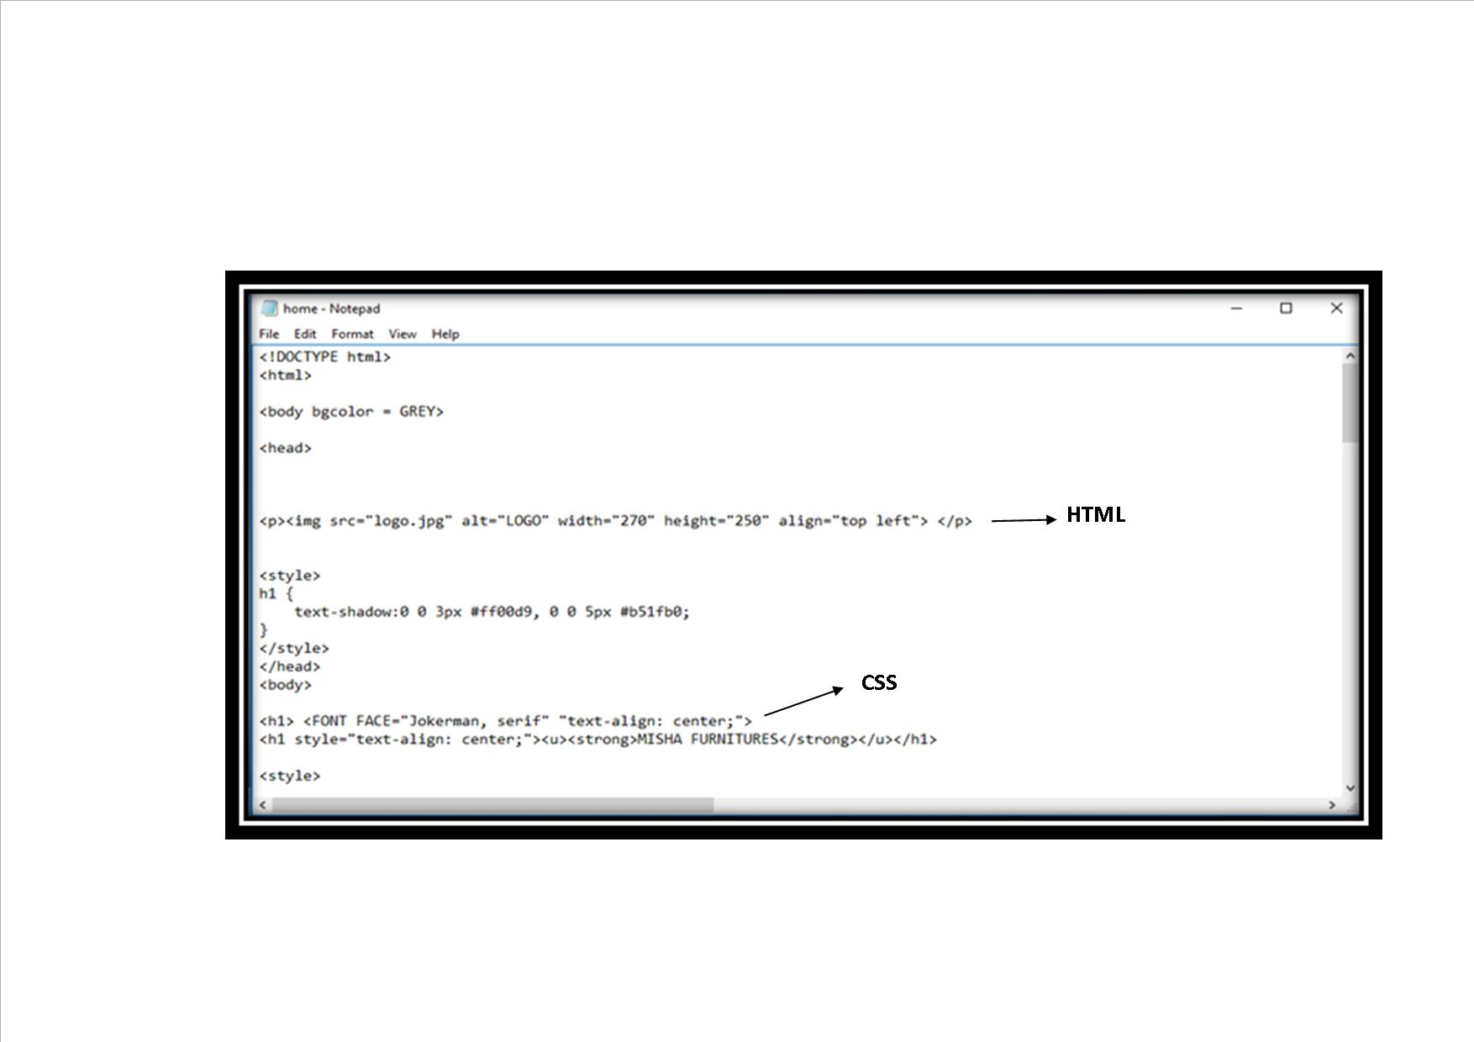

**JavaScript/DOM Scripting**

JavaScript/DOM Scripting is the scripting language that is used to add interactivity and behaviours to web pages. JavaScript is used to manipulate the elements on the web page; the styles applied them, or even the browser itself.

**Server-Side Programming**

Some simple websites are collections of static HTML documents and image files, but most commercial sites have more advance functionality such as forms handling, dynamically generated pages, shopping carts, content management systems, database, and so on. These functions are handled by web applications running on the server. There are a number of programming languages and frameworks that are used to create web applications.

There are a series of guidelines that a web designer needs to follow to make sure site conforms to best practice. These guidelines encompass:

* Browser compatibility
* Screen resolution
* Web accessibility

# WEBSITE WIREFRAMES

|  |
| --- |
| *home page*  Logo  Banner  Image  PICTURE OF SCHOOL (SLIDE SHOW)  VISION  MISSION  MOE LINK  **COPYRIGHT. Legal Disclaimer** |

|  |
| --- |
| *ABOUT PAGE*  Logo  Banner  Image  **BRIEF HISTORY OF SCHOOL**  **LOCATION**  **GOOGLE MAP**  **CONTACT DETAILS** |

***DEPARTMENT***

LOGO

LO

BANNER

|  |  |  |  |  |  |
| --- | --- | --- | --- | --- | --- |
| **HOME** | **ABOUT** | **DEPARTMENT** | **SCHOOL PROGRAM** | **RESOURCES** | **PHOTO GALLERY** |

DESCRIPTION OF THE DEPARTMENT AND MEMBERS

|  |
| --- |
| **ENGLISH** |
| **MATHS/PHYSICS** |
| **COMPUTER STUDIES** |
| **COMMERCE** |
| **SOCIAL SICENCE** |
| **HOME ECONOMICS** |
| **AGRICULTURE SCIENCE** |
| **SCIENCE** |
| **INDUSTRIAL ARTS** |
| **PE** |

***SCHOOL PROGRAMMES***

BANNER

LOGO

|  |  |  |  |  |  |
| --- | --- | --- | --- | --- | --- |
| **HOME** | **ABOUT** | **DEPARTMENT** | **SCHOOL PROGRAM** | **RESOURCES** | **PHOTO GALLERY** |

|  |
| --- |
| SCHOOL CALENDAR |
|  |

DESCRIPTION OF SCHOOL CALENDAR

CO-CURRICULAR ACTIVITIES

DESCRIPTION OF CO-CURRICULAR ACTIVITIES

***RESOURCES***

BANNER

LOGO

|  |  |  |  |  |  |
| --- | --- | --- | --- | --- | --- |
| **HOME** | **ABOUT** | **DEPARTMENT** | **SCHOOL PROGRAM** | **RESOURCES** | **PHOTO GALLERY** |

|  |
| --- |
| MoE PAST YEAR PAPERS |
| MoE TEXT BOOK |
| FIJI GOVERNMENT HOME PAGE |

***PHOTO GALLERY***

LOGO

BANNER

|  |  |  |  |  |  |
| --- | --- | --- | --- | --- | --- |
| **HOME** | **ABOUT** | **DEPARTMENT** | **SCHOOL PROGRAM** | **RESOURCES** | **PHOTO GALLERY** |

|  |
| --- |
| PICTURES OF EVENTS HELD IN SCHOOL |

# WEBPAGE - HOME



# WEBPAGE - ABOUT

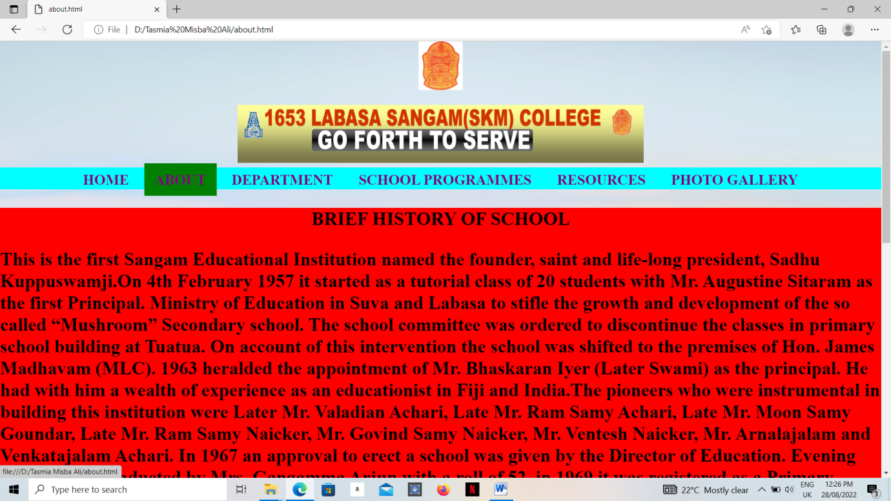

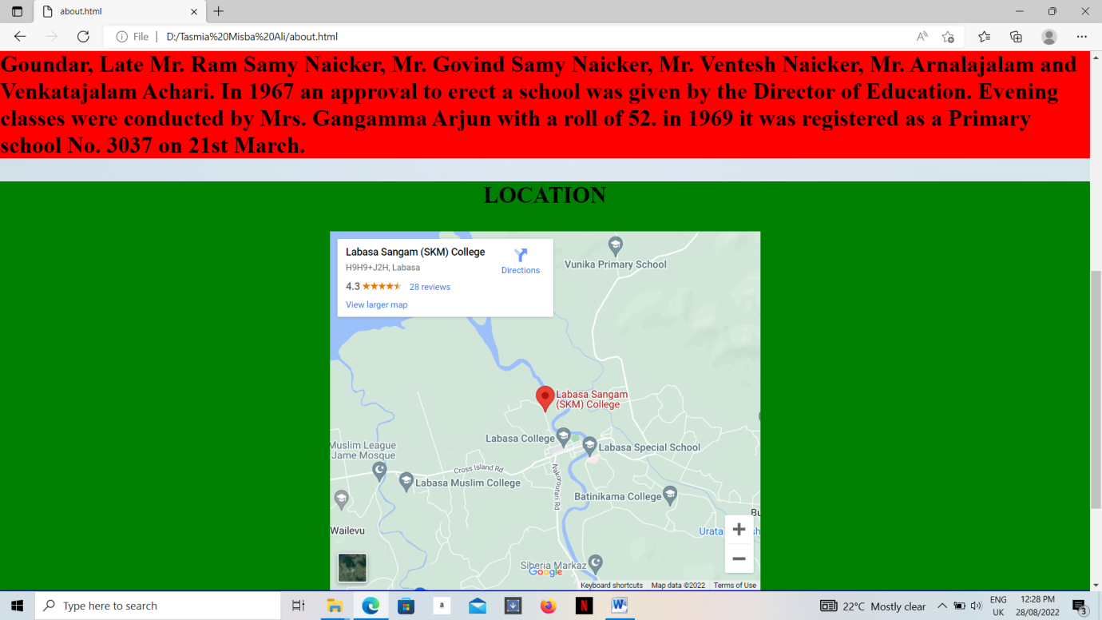

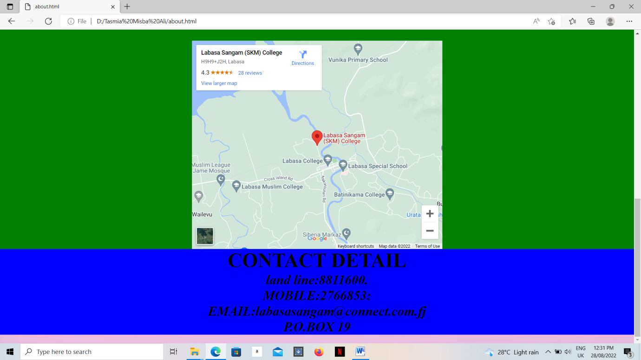

# WEBPAGE - DEPARTMENT

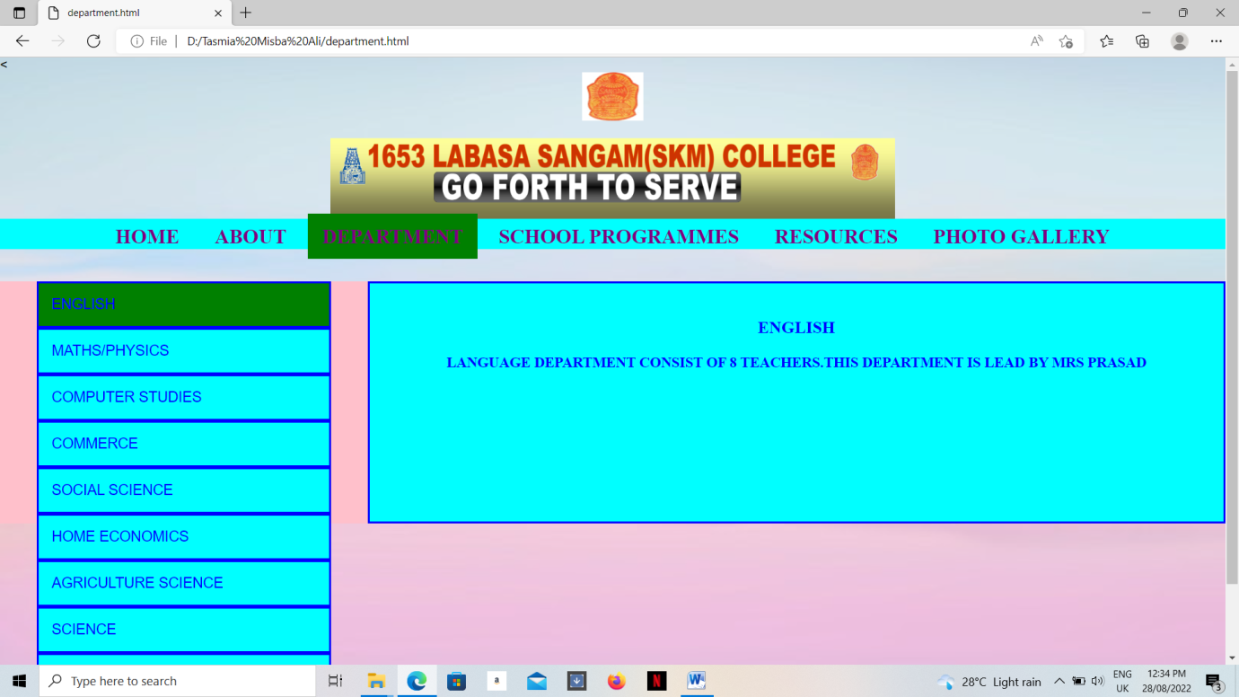

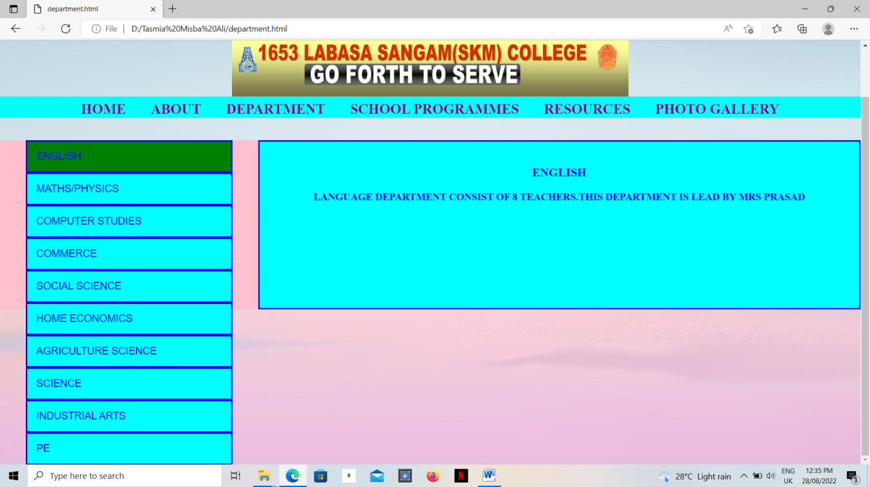

# WEBPAGE - SCHOOL PROGRAMME

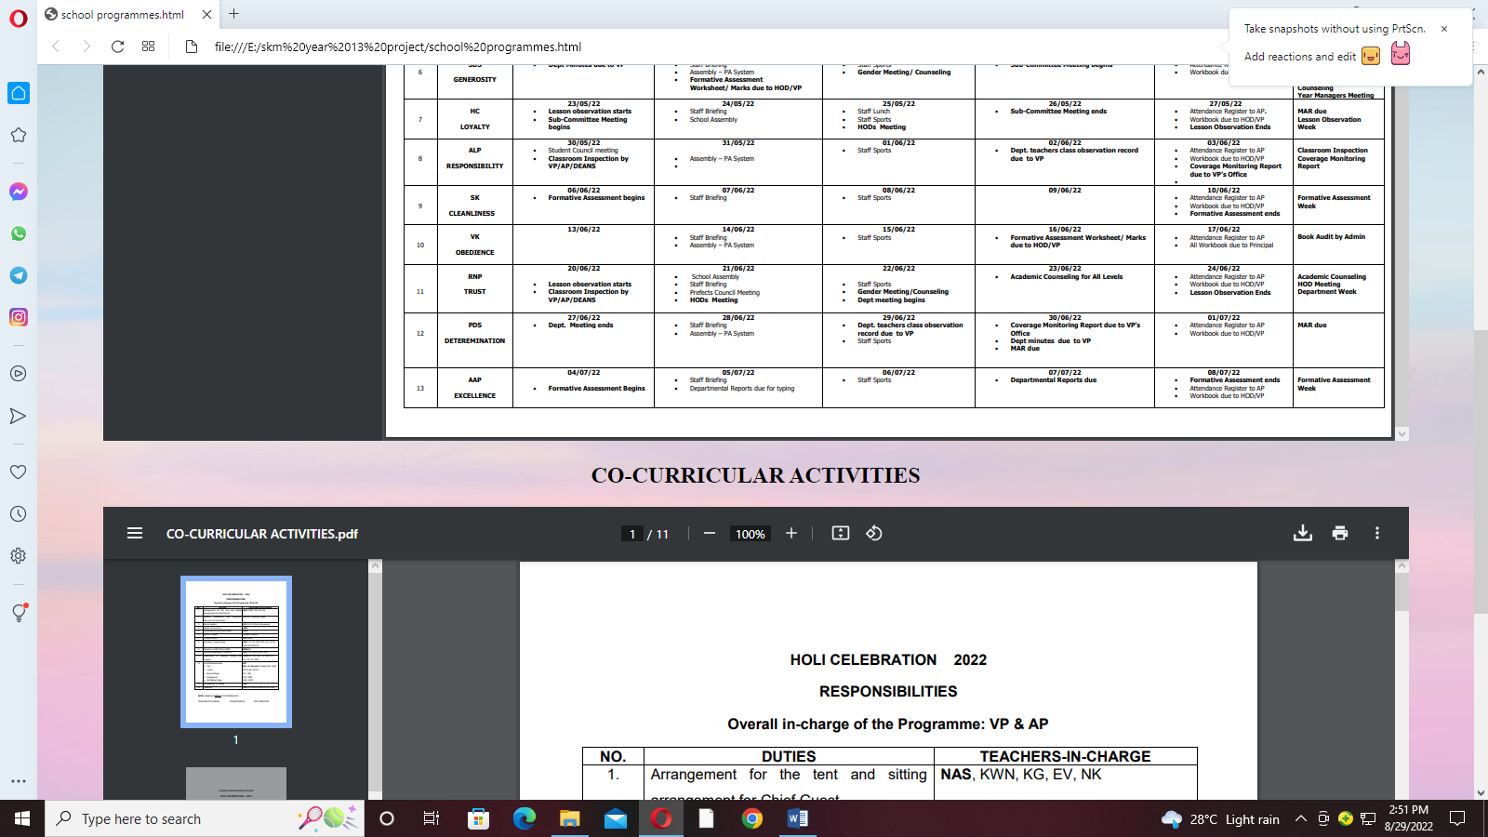

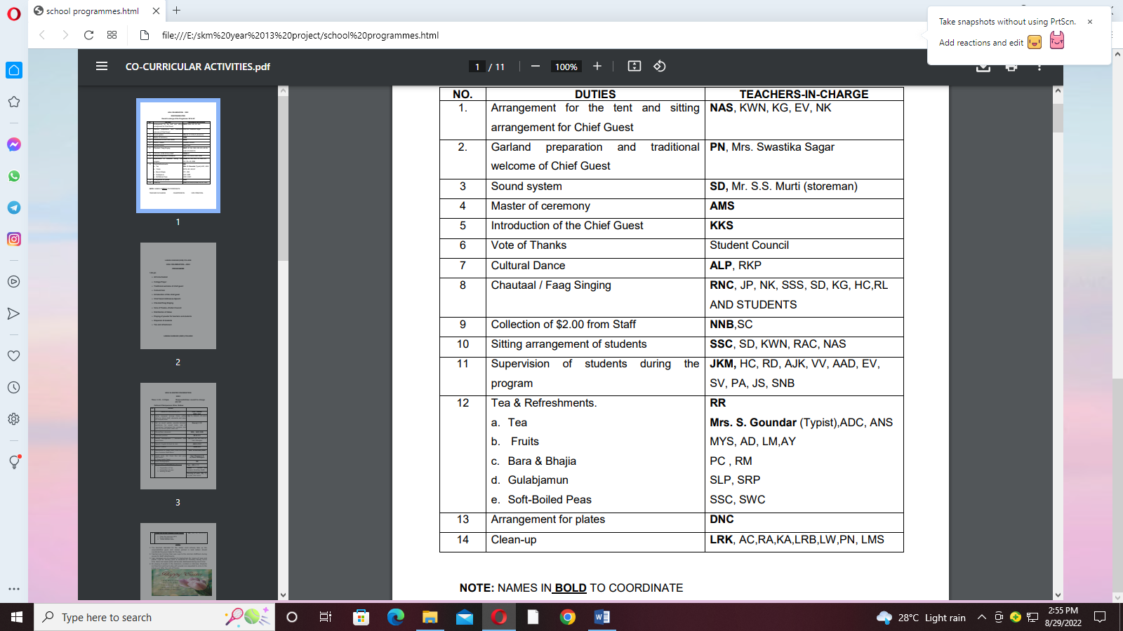

# WEBPAGE - RESOURCES

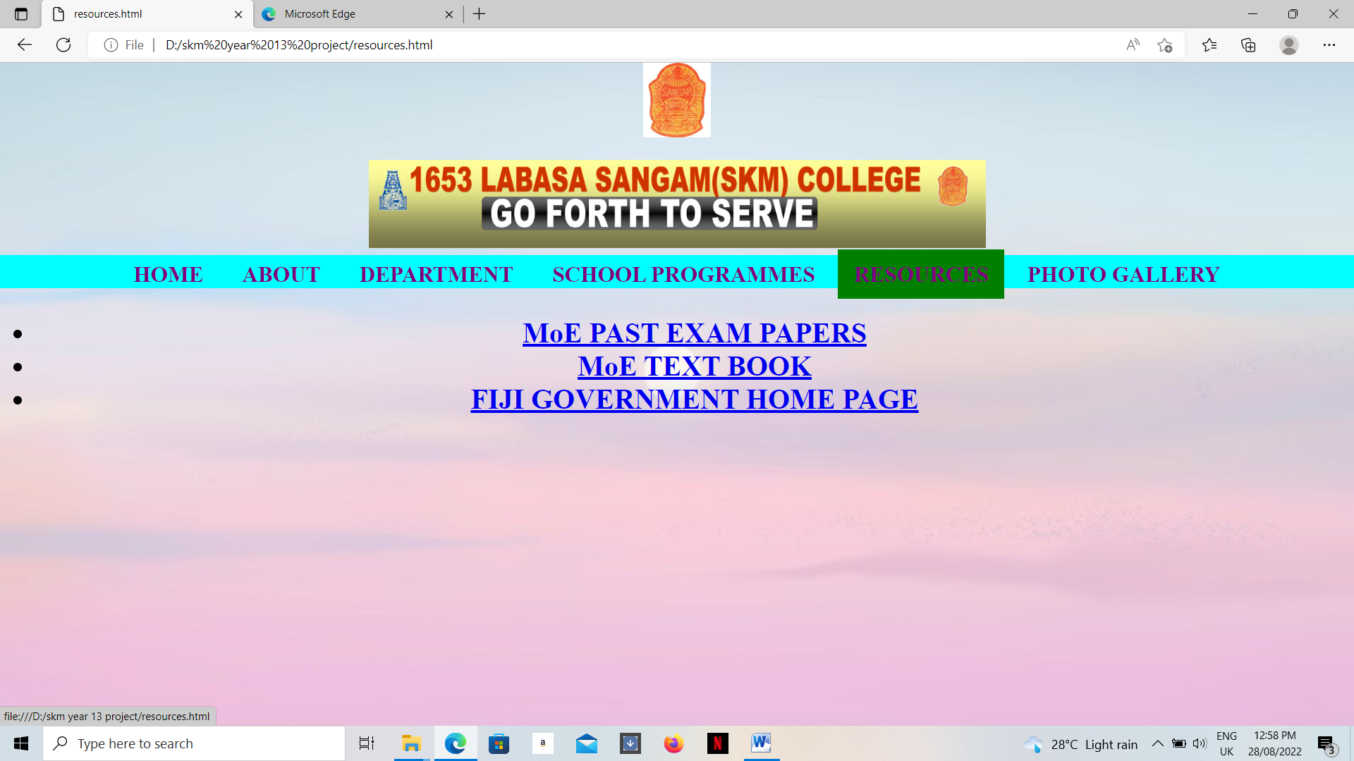

# WEBPAGE – PHOTO GALLERY

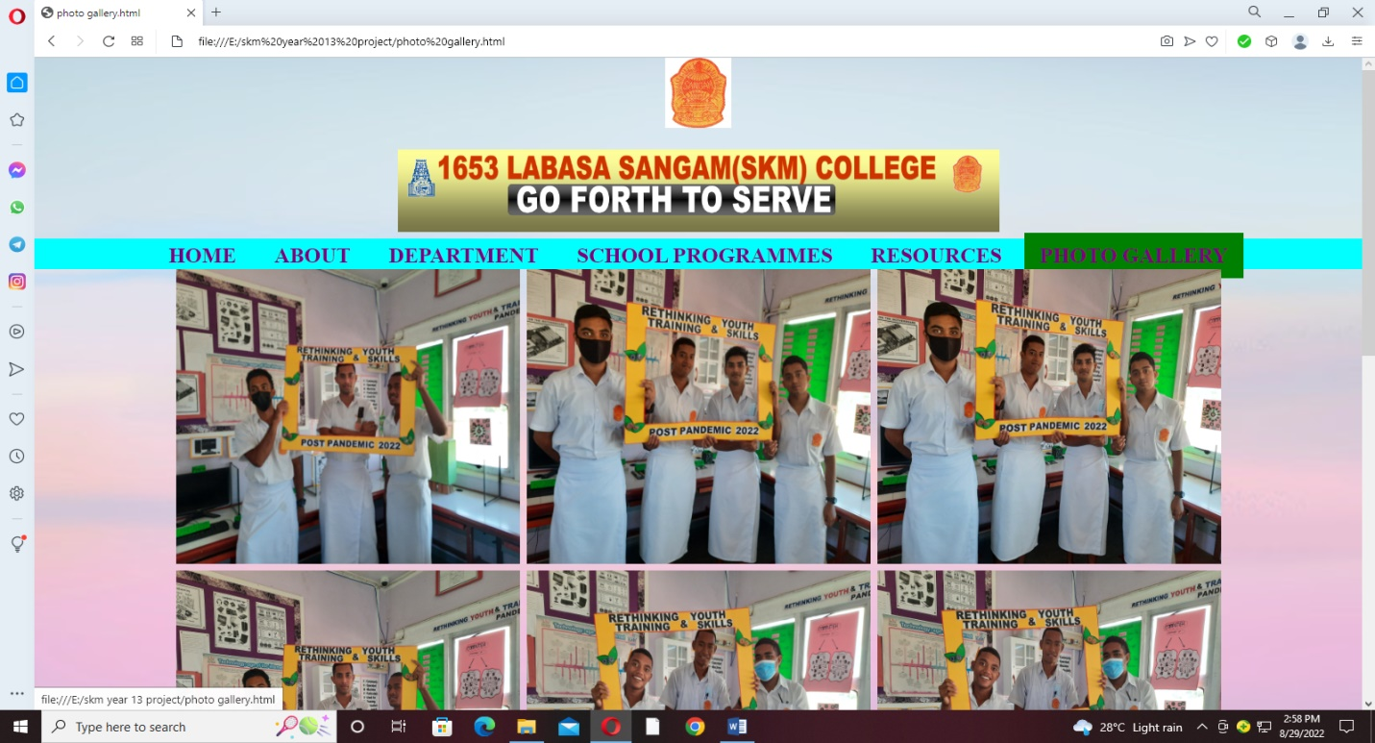

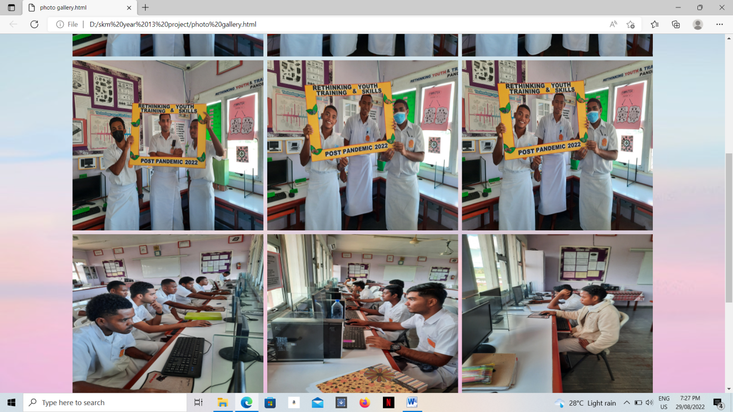

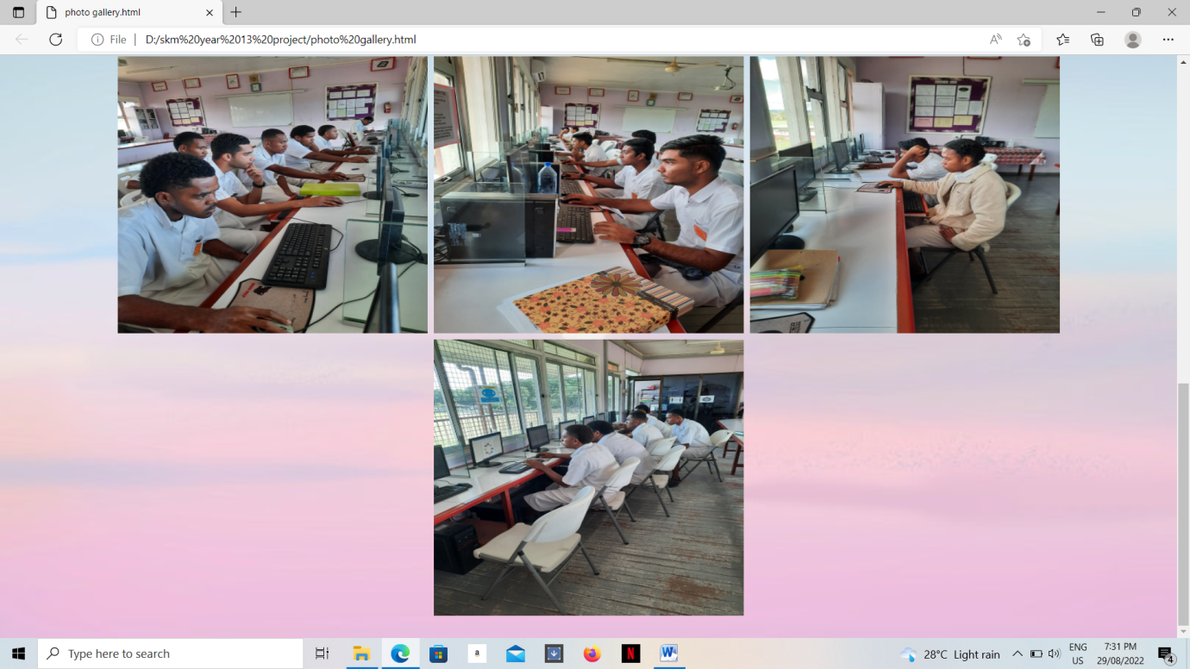

# CODING - HOME

<!DOCTYPE html>

<html

<head>

<center> <img src ="300.jpg" alt = "02" width = "5%" height = "8%" class="center" alt = "img"/></br>

<h1> <FONT FACE="Times" "text-align: center;">

<style>

body{

margin: 0;

background : url('120.jpg');

background-repeat: no-repeat;

background-attachment: fixed;

background-size: cover;

}

body {

margin: CENTRE;

font-family:"Comic Sans MS, serif"

}

.topnav {

overflow: unhidden;

background-color: AQUA;

}

.topnav a {

float: CENTRE;

color: PURPLE;

text-align:CENTRE;

padding: 14px 18px;

text-decoration: none;

font-size: 25px;

}

.topnav a:hover {

background-color: GREEN;

}

.topnav a.active {

background-color: YELLOW;

color:CHOCOLATE;

}

.topnav .icon {

display: none;

}

</style>

# 

# CODING - ABOUT

<!DOCTYPE html>

<html

<head>

<center> <img src ="300.jpg" alt = "02" width = "5%" height = "8%" class="center" alt = "img"/></br>

<h1> <FONT FACE="Times" "text-align: center;">

<style>

body{

margin: 0;

background : url('120.jpg');

background-repeat: no-repeat;

background-attachment: fixed;

background-size: cover;

}

body {

margin: CENTRE;

font-family:"Comic Sans MS, serif"

}

.topnav {

overflow: unhidden;

background-color: AQUA;

}

.topnav a {

float: CENTRE;

color: PURPLE;

text-align:CENTRE;

padding: 14px 18px;

text-decoration: none;

font-size: 25px;

}

.topnav a:hover {

background-color: GREEN;

}

.topnav a.active {

background-color: YELLOW;

color:CHOCOLATE;

}

.topnav .icon {

display: none;

}

</style>

</head>

<body>

</div>

<img src="banner.jpg" alt="banner" width="700" height="100"></br>

<div class="topnav">

<a href = "home.html">HOME</a>

<a href = "about.html">ABOUT</a>

<a href = "department.html">DEPARTMENT</a>

<a href = "school programmes.html">SCHOOL PROGRAMMES</a>

<a href = "resources.html">RESOURCES</a>

<a href = "photo gallery.html">PHOTO GALLERY</a>

</div>

<div style="background-color:RED ">

<p>BRIEF HISTORY OF SCHOOL</p>

<p align="Left"> This is the first Sangam Educational Institution named the founder, saint and life-long president, Sadhu Kuppuswamji.On 4th February 1957 it started as a tutorial class of 20 students with Mr. Augustine Sitaram as the first Principal. Ministry of Education in Suva and Labasa to stifle the growth and development of the so called “Mushroom” Secondary school. The school committee was ordered to discontinue the classes in primary school building at Tuatua. On account of this intervention the school was shifted to the premises of Hon. James Madhavam (MLC).

1963 heralded the appointment of Mr. Bhaskaran Iyer (Later Swami) as the principal. He had with him a wealth of experience as an educationist in Fiji and India.The pioneers who were instrumental in building this institution were Later Mr. Valadian Achari, Late Mr. Ram Samy Achari, Late Mr. Moon Samy Goundar, Late Mr. Ram Samy Naicker, Mr. Govind Samy Naicker, Mr. Ventesh Naicker, Mr. Arnalajalam and Venkatajalam Achari. In 1967 an approval to erect a school was given by the Director of Education. Evening classes were conducted by Mrs. Gangamma Arjun with a roll of 52. in 1969 it was registered as a Primary school No. 3037 on 21st March.</p>

</div>

<div style="background-color:GREEN ">

<p>LOCATION </p>

<div class="mapouter"><div class="gmap_canvas"><iframe width="600" height="500" id="gmap_canvas"

src="https://maps.google.com/maps?q=LABASA%20SANGAM%20(SKM)%20COLLEGE&t=&z=13&ie=UTF8&iwloc=&output=embed" frameborder="0"

scrolling="no" marginheight="0" marginwidth="0"></iframe><a href="https://www.whatismyip-address.com/divi-discount/">divi

discount</a><br><style>.mapouter{position:relative;text-align:right;height:500px;width:600px;}</style><a

href="https://www.embedgooglemap.net">embedgooglemap.net</a><style>.gmap_canvas

{overflow:hidden;background:none!important;height:500px;width:600px;}</style></div></div>

</div>

<div style="background-color:BLUE">

<font face="TIMES NEW ROMAN" color="BLACK" size="8"> <center> <b> CONTACT DETAIL </b> </font>

<address>

land line:8811600</a>.<br>

MOBILE:2766853:<br>

EMAIL:labasasangam@connect.com.fj<br>

P.O.BOX 19<br>

</address>

</body>

</html>

# CODING - DEPARTMENT

<<!DOCTYPE html>

<html

<head>

<center> <img src ="300.jpg" alt = "02" width = "5%" height = "8%" class="center" alt = "img"/></br>

<h1> <FONT FACE="Times" "text-align: center;">

<style>

body{

margin: 0;

background : url('120.jpg');

background-repeat: no-repeat;

background-attachment: fixed;

background-size: cover;

}

body {

margin: CENTRE;

font-family:"Comic Sans MS, serif"

}

.topnav {

overflow: unhidden;

background-color: AQUA;

}

.topnav a {

float: CENTRE;

color: PURPLE;

text-align:CENTRE;

padding: 14px 18px;

text-decoration: none;

font-size: 25px;

}

.topnav a:hover {

background-color: GREEN;

}

.topnav a.active {

background-color: YELLOW;

color:CHOCOLATE;

}

.topnav .icon {

display: none;

}

</style>

</head>

<body>

</div>

<img src="banner.jpg" alt="banner" width="700" height="100"></br>

<div class="topnav">

<a href = "home.html">HOME</a>

<a href = "about.html">ABOUT</a>

<a href = "department.html">DEPARTMENT</a>

<a href = "school programmes.html">SCHOOL PROGRAMMES</a>

<a href = "resources.html">RESOURCES</a>

<a href = "photo gallery.html">PHOTO GALLERY</a>

</div>

<head>

<meta name="viewport" content="width=device-width, initial-scale=1">

<style>

* {box-sizing: border-box}

body {font-family: "Lato", sans-serif;}

.tab {

float: left;

border:none;

background-color:pink;

width: 30%;

height: 300px;

}

.tab button {

display: block;

background-color: aqua;

color: blue;

padding: 16px 16px;

width: 80%;

border: solid;

outline: none;

text-align: left;

cursor: pointer;

transition: 0.3s;

font-size: 18px;

}

.tab button:hover {

background-color: pink;

}

.tab button.active {

background-color: green;

}

.tabcontent {

float: left;

padding: 0px 12px;

border: solid blue;

width: 70%;

border-left:solid blue;

height: 300px;

display: block;

background-color: aqua;

color: blue;

font-size: 18px;

padding: 22px 16px;

}

</style>

</head>

<body>

<h2></h2>

<p></p>

<div class="tab">

<button class="tablinks"onclick="openDepartment(event,'ENGLISH')"id="defaultOpen">ENGLISH</button>

<button class="tablinks"onclick="openDepartment(event,'MATHS/PHYSICS')">MATHS/PHYSICS</button>

<button class="tablinks"onclick="openDepartment(event,'COMPUTER STUDIES')">COMPUTER STUDIES</button>

<button class="tablinks"onclick="openDepartment(event,'COMMERCE')">COMMERCE</button>

<button class="tablinks"onclick="openDepartment(event,'SOCIAL SCIENCE')">SOCIAL SCIENCE</button>

<button class="tablinks"onclick="openDepartment(event,'HOME ECONOMICS')">HOME ECONOMICS</button>

<button class="tablinks"onclick="openDepartment(event,'AGRICULTURE SCIENCE')">AGRICULTURE SCIENCE</button>

<button class="tablinks"onclick="openDepartment(event,'SCIENCE')">SCIENCE</button>

<button class="tablinks"onclick="openDepartment(event,'INDUSTRIAL ARTS')">INDUSTRIAL ARTS</button>

<button class="tablinks"onclick="openDepartment(event,'PE')">PE</button>

</div>

<div id="ENGLISH" class="tabcontent">

<h3>ENGLISH</h3>

<p>LANGUAGE DEPARTMENT CONSIST OF 8 TEACHERS.THIS DEPARTMENT IS LEAD BY MRS PRASAD</p>

</div>

<div id="MATHS/PHYSICS" class="tabcontent">

<h3>MATHS/PHYSICS</h3>

<p>MATHS/PHYSICS DEPARTMENT IS LEAD MR HARNESH CHAND. THIS DEPARTMENT CONSIST OF 9 TEACHERS.</p>

</div>

<div id="COMPUTER STUDIES" class="tabcontent">

<h3>COMPUTER STUDIES</h3>

<p>COMPUTER SCIENCE DEPARTMENT IS LEAD MRS.AHMAD. THIS DEPARTMENT CONSIST OF 3 TEACHERS.</p>

<br><center><img src ="S3.jpg" alt = "S3" width = "30%" height = "30%" alt = "img"/></br>

</div>

<div id="COMMERCE" class="tabcontent">

<h3>COMMERCE</h3>

<p>COMMERCE DEPARTMENT IS LEAD MR. DEO. THIS DEPARTMENT CONSIST OF 7 TEACHERS..</p>

</div>

<div id="SOCIAL SCIENCE" class="tabcontent">

<h3>SOCIAL SCIENCE</h3>

<p>SOCIAL SCIENCE DEPARTMENT IS LEAD MRS.NAICKER. THIS DEPARTMENT CONSIST OF 5 TEACHERS.</p>

</div>

<div id="HOME ECONOMICS" class="tabcontent">

<h3>HOME ECONOMICS</h3>

<p>HOME ECONOMICS IS LEAD MRS SANGEETA WATI. THIS DEPARTMENT CONSIST OF 3 TEACHERS..</p>

</div>

<div id="AGRICULTURE SCIENCE" class="tabcontent">

<h3>AGRICULTURE SCIENCE</h3>

<p>AGRICULTURE DEPARTMENT IS LEAD MR SARWAN KUMAR. THIS DEPARTMENT CONSIST OF 4 TEACHERS.</p>

</div>

<div id="SCIENCE" class="tabcontent">

<h3>SCIENCE</h3>

<p>CIENCE DEPARTMENT IS LEAD MR ROHITESH CHANDRA. THIS DEPARTMENT CONSIST OF 7 TEACHERS.</p>

</div>

<div id="INDUSTRIAL ARTS" class="tabcontent">

<h3>INDUSTRIAL ARTS</h3>

<p>INDUSTRIAL ARTS DEPARTMENT IS LEAD MR ROMEEN CHANDRA. THIS DEPARTMENT CONSIST OF 4 TEACHERS.</p>

</div>

<div id="PE" class="tabcontent">

<h3>PE</h3>

<p>PEMAC DEPARTMENT IS LEAD MR. VILI. THIS DEPARTMENT CONSIST OF 2 TEACHERS.</p>

</div>

<script>

function openDepartment(evt, DepartmentName) {

var i, tabcontent, tablinks;

tabcontent = document.getElementsByClassName("tabcontent");

for (i = 0; i < tabcontent.length; i++) {

tabcontent[i].style.display = "none";

}

tablinks = document.getElementsByClassName("tablinks");

for (i = 0; i < tablinks.length; i++) {

tablinks[i].className = tablinks[i].className.replace(" active", "");

}

document.getElementById(DepartmentName).style.display = "block";

evt.currentTarget.className += " active";

}

document.getElementById("defaultOpen").click();

</script>

</body>

</html>

# CODING - SCHOOL PROGRAM

<!DOCTYPE html>

<html

<head>

<center> <img src ="300.jpg" alt = "02" width = "5%" height = "8%" class="center" alt = "img"/></br>

<h1> <FONT FACE="Times" "text-align: center;">

<style>

body{

margin: 0;

background : url('120.jpg');

background-repeat: no-repeat;

background-attachment: fixed;

background-size: cover;

}

body {

margin: CENTRE;

font-family:"Comic Sans MS, serif"

}

.topnav {

overflow: unhidden;

background-color: AQUA;

}

.topnav a {

float: CENTRE;

color: PURPLE;

text-align:CENTRE;

padding: 14px 18px;

text-decoration: none;

font-size: 25px;

}

.topnav a:hover {

background-color: GREEN;

}

.topnav a.active {

background-color: YELLOW;

color:CHOCOLATE;

}

.topnav .icon {

display: none;

}

</style>

</head>

<body>

</div>

<img src="banner.jpg" alt="banner" width="700" height="100"></br>

<div class="topnav">

<a href = "home.html">HOME</a>

<a href = "about.html">ABOUT</a>

<a href = "department.html">DEPARTMENT</a>

<a href = "school programmes.html">SCHOOL PROGRAMMES</a>

<a href = "resources.html">RESOURCES</a>

<a href = "photo gallery.html">PHOTO GALLERY</a>

</div>

<body style="margin:0px;">

<h2style= font-size:20px font face:Times New Roman align:center>TERM CALENDAR</h2>

<embed src="Term 1 Calendar 2022.pdf" style="width:90vw;height:100vh;"/>

<body style="margin:0px;">

<h2>CO-CURRICULAR ACTIVITIES</h2>

<embed src="CO-CURRICULAR ACTIVITIES.pdf" style="width:90vw;height:100vh;"/>

</div>

</body>

</html>

# 

# CODING - RESOURCES

<!DOCTYPE html>

<html

<head>

<center> <img src ="300.jpg" alt = "02" width = "5%" height = "8%" class="center" alt = "img"/></br>

<h1> <FONT FACE="Times" "text-align: center;">

<style>

body{

margin: 0;

background : url('120.jpg');

background-repeat: no-repeat;

background-attachment: fixed;

background-size: cover;

}

body {

margin: CENTRE;

font-family:"Comic Sans MS, serif"

}

.topnav {

overflow: unhidden;

background-color: AQUA;

}

.topnav a {

float: CENTRE;

color: PURPLE;

text-align:CENTRE;

padding: 14px 18px;

text-decoration: none;

font-size: 25px;

}

.topnav a:hover {

background-color: GREEN;

}

.topnav a.active {

background-color: YELLOW;

color:CHOCOLATE;

}

.topnav .icon {

display: none;

}

</style>

</head>

<body>

</div>

<img src="banner.jpg" alt="banner" width="700" height="100"></br>

<div class="topnav">

<a href = "home.html">HOME</a>

<a href = "about.html">ABOUT</a>

<a href = "department.html">DEPARTMENT</a>

<a href = "school programmes.html">SCHOOL PROGRAMMES</a>

<a href = "resources.html">RESOURCES</a>

<a href = "photo gallery.html">PHOTO GALLERY</a>

</div>

<body>

<ul>

<li><a href="https://www.google.com/search?client=firefox-b-d&q=past+exam+papers">MoE PAST EXAM PAPERS</a></li>

<li><a href="https://www.google.com/search?client=firefox-b-d&q=TEXT+BOOK">MoE TEXT BOOK</a></li>

<li><a href="https://www.google.com/search?client=firefox-b-d&q=GOVERNMENT+WEBSITE">FIJI GOVERNMENT HOME PAGE</a></li>

</body>

</html>

# CODING – PHOTO GALLERY

<!DOCTYPE html>

<html

<head>

<center> <img src ="300.jpg" alt = "02" width = "5%" height = "8%" class="center" alt = "img"/></br>

<h1> <FONT FACE="Times" "text-align: center;">

<style>

body{

margin: 0;

background : url('120.jpg');

background-repeat: no-repeat;

background-attachment: fixed;

background-size: cover;

}

body {

margin: CENTRE;

font-family:"Comic Sans MS, serif"

}

.topnav {

overflow: unhidden;

background-color: AQUA;

}

.topnav a {

float: CENTRE;

color: PURPLE;

text-align:CENTRE;

padding: 14px 18px;

text-decoration: none;

font-size: 25px;

}

.topnav a:hover {

background-color: GREEN;

}

.topnav a.active {

background-color: YELLOW;

color:CHOCOLATE;

}

.topnav .icon {

display: none;

}

</style>

</head>

<body>

</div>

<img src="banner.jpg" alt="banner" width="700" height="100"></br>

<div class="topnav">

<a href = "home.html">HOME</a>

<a href = "about.html">ABOUT</a>

<a href = "department.html">DEPARTMENT</a>

<a href = "school programmes.html">SCHOOL PROGRAMMES</a>

<a href = "resources.html">RESOURCES</a>

<a href = "photo gallery.html">PHOTO GALLERY</a>

</div>

<img src="TEST 1.jpg" alt="TEST 1" width="400" height="357">

<img src="TEST 2.jpg" alt="TEST 2" width="400" height="357">

<img src="TEST 3.jpg" alt="TEST 3" width="400" height="357">

<img src="TEST 4.jpg" alt="TEST 4" width="400" height="357">

<img src="TEST 5.jpg" alt="TEST 5" width="400" height="357">

<img src="TEST 6.jpg" alt="TEST 6" width="400" height="357">

<img src="TEST 7.jpg" alt="TEST 7" width="400" height="357">

<img src="TEST 8.jpg" alt="TEST 8" width="400" height="357">

<img src="TEST 9.jpg" alt="TEST 9" width="400" height="357">

<img src="TEST 10.jpg"alt="TEST 10" width="400" height="357">

</img>

</body>

</html>

# RESULTS

**BENEFITS OF HAVING A WEBSITE**

Upper hand

The site mirrors the school with regards to values, mentality towards possibilities and acknowledgment of current patterns. Such an improvement will give your school an upper hand and assist you with separating yourself from the opposition.

To capitalize on the open door, investigate the sites of different schools in the locale. What sort of highlights do these sites have and can anyone explain this? A tad of contest examination can assist you with getting enlivened. You will effectively sort out some way to situate yourself and make the most engaging persona for your foundation.

The Most Efficient Type of Marketing

Having a site is the substance of each and every web based showcasing methodology. The quantity of individuals searching for data online is developing constantly. In the event that you come up short on reasonable web-based presence, you are passing up on an extraordinary chance to publicize your school.

Internet advertising has many countenances. It can come as a substance based technique, web-based entertainment showcasing, YouTube recordings or pay per click (PPC) crusades. To create utilization of these open doors, in any case, you really want a greeting page.

This sort of publicizing is profoundly designated - you will contact individuals that have a specific interest in the open door gave. It is additionally significantly more expense effective than paying for conventional advancement like TV promotion spots or outside boards.

Reaching Prospects

Guardians will frequently be searching for helpful chances to contact school organization and get their inquiries addressed. Site advancement gives prospects this sort of correspondence choice.

A site could have a contact structure or even live talk to address the worries and the enquiries of possibilities. Working with correspondence will frequently convert into better open doors for expanding the ubiquity of your school and becoming the quantity of understudies.

You really want a truly essential site to achieve these objectives. It can comprise of only several pages yet take care of business.

# CONCLUSION

Upon the finish of this adventure it might be said that the focuses and targets arranged were reasonably achieved. The endeavour examined the points of view and sights of clients in their technique for use online as whole in the web period to improve the school.

Besides, one more proposed lab was fixed up and redesigned subsequent to wanting to work on the learning and showing air thusly it will in general be upheld as a sharp hypothesis advantage for a seriously prolonged stretch of time to come to make the client more relish the experience of gobbling up and making on the web. Various respondents and examination moved for different substance of the new site accordingly, considering benefits and better receptiveness to client's plain and ease were taken into proposed and were installed on.

Plus, as a gave web expert conveying the positions in making new look of the school page was the onus on the various accomplices to utilize the new headway to most outrageous benefit thusly it is exceptionally endorsed that schools to deal with bigger scope from online openness to detached consideration.

# 

# REFERENCE

Christensson, P. (2005). *About Us: Tech Terms*. Retrieved July 15, 2019, from Tech Terms: https://techterms.com/definition/web_design

Hopkins, J. (1979). *the Johns Hopkins Center for Talented Youth*. Retrieved July 12, 2019, from John Hopkins Website: https://cty.jhu.edu/online/courses/computer_science/intro_web_design.html

R.Hussain. (2015). Ministry of Education. In *Computer Studies Year 13* (pp. 100-111). Suva,Fiji: Ministry of Education,Heritage and Arts.

(<https://www.technojobs.co.uk/info/it-job-roles/the-role-of-a-web-designer.phtml>)